**Key Generation and Remote Connection (SSH)**

SSH, or Secure Shell, is a cryptographic network protocol used for secure communication between devices over a computer network. It is commonly used for remote command execution, login, and data transfer, as well as tunnelling other network protocols through firewalls. SSH plays a critical role in maintaining security and privacy in computer networks by providing a secure and encrypted connection between two devices, preventing unauthorized access, eavesdropping, and tampering.

In this project, we will walk through the process of generating SSH keys and securely connecting two devices using SSH. The main objective of this project is to demonstrate a understanding of the SSH key generation process and the steps involved in securely connecting two devices using SSH.

To check if the SSH server (sshd) is running on a Linux machine, you can use the following methods:

1. **Ps command**: Use the $ **ps aux | grep sshd** command to list all processes related to sshd. If the SSH server is running, you should see an entry with the sshd process ID (PID).
2. **Netstat command**: Use the $ **netstat -plant | grep :22** command to check if the SSH server is listening on the default port (22). If it is, you should see an entry with the sshd (PID) and the 'LISTEN' state.
3. **Lsof command**: Use the $ **lsof -i :22** command to list open TCP connections and their corresponding PIDs on port 22. If the SSH server is running, you should see an entry with the sshd (PID).
4. **Systemctl command**: If your Linux distribution uses systemd, you can use the $ **systemctl status ssh** command to check the status of the SSH server.
5. **SSH –v command**: This command will display the version of SSH installed on your device, if it is installed. If SSH is not installed, you will receive an error message indicating that the command is not found. If SSH is not installed, you can install it using your device's package manager. For example, on Debian or Ubuntu distributions, use the command $ **sudo apt-get install openssh-client**, and on Kali or Red-hat distributions, use the command $ **sudo yum install openssh-clients**.

By mastering the SSH key generation process and secure device connection, you can ensure secure communication between devices and protect sensitive data and systems from unauthorized access, eavesdropping, and tampering.

**Generating SSH Keys**

To generate SSH keys, use the basic command **ssh-keygen**. This command creates a pair of cryptographic keys, a public key and a private key, used for secure communication between devices.

**Step 1. Run the SSH-Keygen Command**

Execute the $ **ssh-keygen** command to generate a new SSH key pair. This command will prompt you to enter a file in which to save the key. You can press enter to accept the default location or specify a different directory path.

**Step 2. Choose a Passphrase**

Next, you will be prompted to enter a passphrase or password to protect your SSH key. It is recommended to use a strong passphrase and keep it safe, as it will be used to encrypt your private key.



**Transferring SSH Key to Remote Device: The Steps**

To transfer your SSH key to a remote device, you can use the following command: $ **ssh-copy-id user@remote-ipaddr**

Where:

* **user** is the remote device user
* **remote-ipaddr** is the IP address of the remote device. You can use the **ifconfig** command to check the IP address.

After running the **ssh-copy-id** command, you will be prompted to enter the password of the remote server. Once the transfer is complete, you can connect to the remote device using the following command: $ ssh remote_user@remote_ipaddr

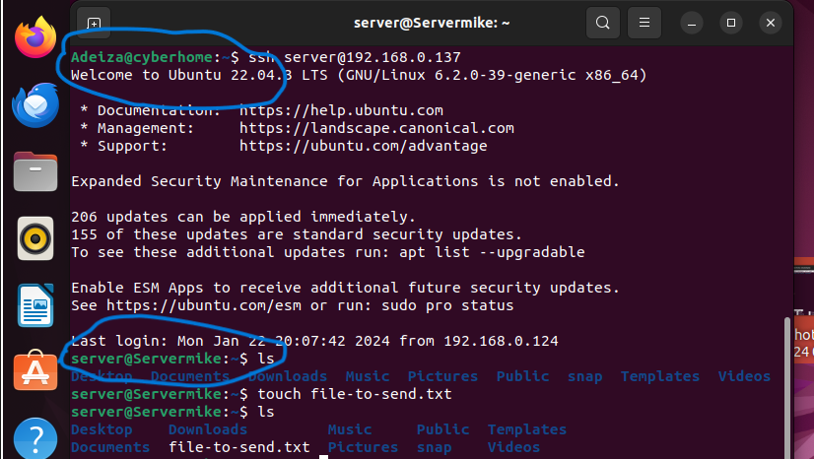

By mastering the SSH key generation process and secure device connection, you can ensure secure communication between devices and protect sensitive data and systems from unauthorized access, eavesdropping, and tampering. This skill is essential as it allows you to securely manage and maintain computer networks.

**SSH Best Practices**

When working with SSH, it is essential to follow best practices to ensure secure communication between devices. Here are some best practices to consider:

1. **Key Pair Management**: Properly manage SSH key pairs by keeping your private key secure and protecting it with a strong passphrase. Regularly review and rotate your SSH keys to ensure their integrity and security.
2. **Disabling Root Login**: Disable root login over SSH to prevent unauthorized access to your system. Instead, use a regular user account with **sudo** privileges to perform administrative tasks.
3. **Limiting User Access**: Limit user access to SSH by only allowing authorized users to connect to your system. Regularly review and manage user access to ensure that only necessary users have access to your system.
4. **Keeping SSH Software Updated**: Regularly update SSH software to ensure that you have the latest security patches and features.
5. **Using Alternative SSH Implementations**: Consider using alternative SSH implementations like Dropbear or OpenSSH to provide additional security features and options.

**Challenges Faced**

While working with SSH, you may encounter challenges related to the SSH server's listening port. By default, the SSH server listens on port 22. However, sometimes the sshd might not be listening on its default port. In such cases, you can configure the sshd to listen on a different port or specify the port you want to connect on.

To change the SSH server's listening port, add the **port** option to the SSH server configuration file, usually located at **/etc/ssh/sshd_config**. For example, to change the SSH server's listening port to 2222, modify the **/etc/ssh/sshd_config** file as follows:

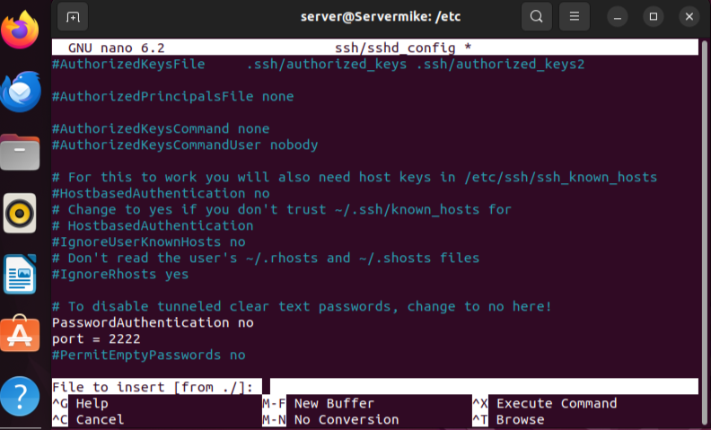

After modifying the configuration file, restart the SSH server to apply the changes. On Ubuntu or Debian distributions, use the command $ **sudo systemctl restart ssh**.

To enhance security, we implemented the following best practices:

1. **Disabling Password Authentication**: We disabled password authentication, which means that only users with a valid SSH key pair can log in to the server. This provides an additional layer of security and protects against brute-force attacks.
2. **Changing the Listening Port**: We changed the SSH server's listening port to a non-standard port. This makes it more difficult for attackers to discover and brute-force the system, as they would need to guess both the non-standard port number and the private key.

In conclusion, the exploration of SSH keygen, key management, secure connections, and best practices has been an enlightening and rewarding experience. By delving into the workings of SSH keygen, I have gained a deeper understanding of the importance of secure key management in maintaining the integrity and confidentiality of sensitive data.

Furthermore, the implementation of secure connections has reinforced the significance of robust security measures in protecting against unauthorized access and ensuring the confidentiality and integrity of data. The adherence to best practices has also highlighted the need for a comprehensive and proactive approach to cybersecurity, incorporating regular updates, monitoring, and risk assessments.

Throughout the course of this project, my keen interest and eagerness to learn have been a driving force in my success. My willingness to go above and beyond, ask questions, and seek out new knowledge has allowed me to expand my skillset and deepen my understanding of cybersecurity concepts.

As I continue to grow and develop in this field, I am confident that my passion for learning and dedication to cybersecurity best practices will serve me well. I am excited to build upon the knowledge and skills gained from this project and to continue exploring new and innovative ways to protect against cyber threats and promote secure online environments.